**Voyage Vista: Illuminating Insights from Uber Expeditionary Analysis**

Project Description

***Uber is a multinational transportation network company that operates a ride-hailing platform. It was founded in 2009 by Garrett Camp and Travis Kalanick and is based in San Francisco, California. Uber provides a convenient way for individuals to request rides from drivers who use their own personal vehicles.***

***Uber Driver Analysis refers to the Analyzing the number of trips taken by Uber drivers can provide insights into their overall activity and the demand for rides in specific areas. Daily, Weekly, or Monthly Analysis: Uber's data can be analyzed on a daily, weekly, monthly basis to understand the trends and patterns of trip volumes. This analysis can help identify peak hours or days of high demand and optimize driver availability during those times. Trips can be analyzed based on geographic regions or specific cities to identify areas with higher demand. This analysis can help Uber drivers decide where to focus their driving efforts for maximum efficiency and profitability. The Major of our project is to use data Analyzing techniques to find unknown patterns in the Uber Drives dataset. The research is carried out on Uber drives data collected from the year 2016.***

***Purpose:-***

This analysis can help Uber drivers decide where to focus their driving efforts for maximum efficiency and profitability. The Major of our project is to use **data Analyzing techniques to find unknown patterns in the Uber Drives dataset. The research is carried out on Uber drives data collected from the year 2016**.

***2. Problem definition& design thinking***

***2.1 Empathy Map***

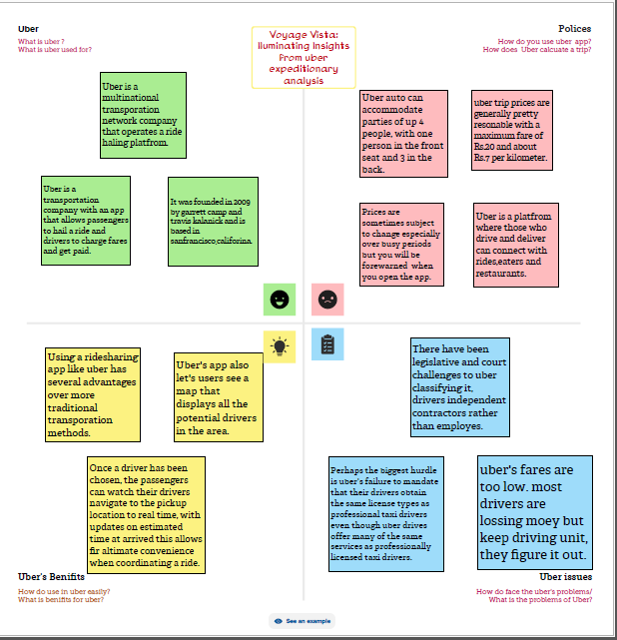

***2.2 Ideation& Brainstorming Map***

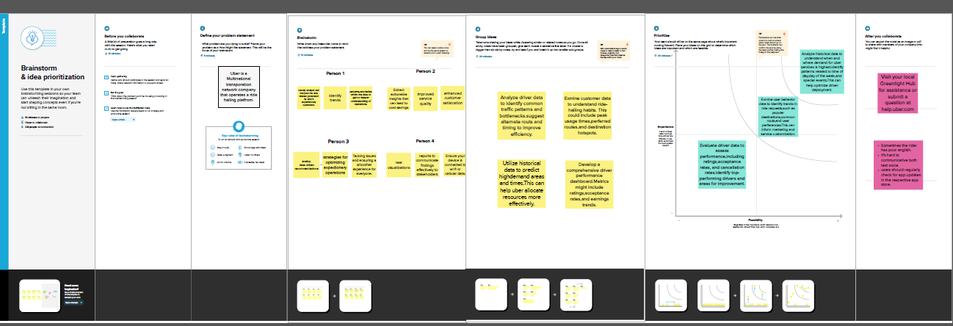

***3. RESULT***

***3.1 Final findings (output)of the project along with screenshot***

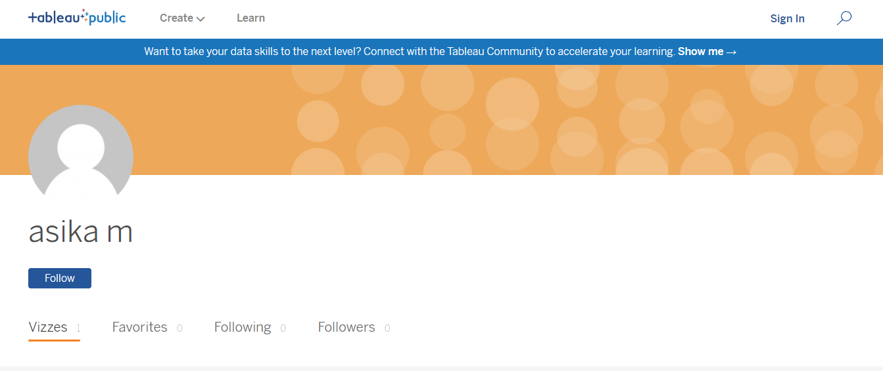

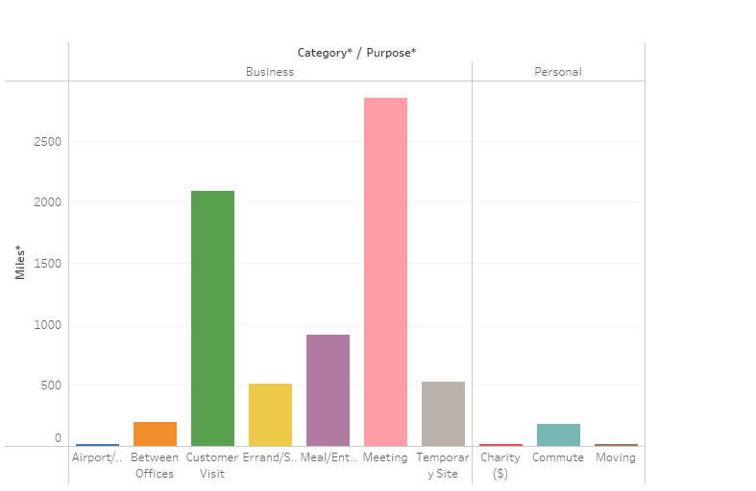

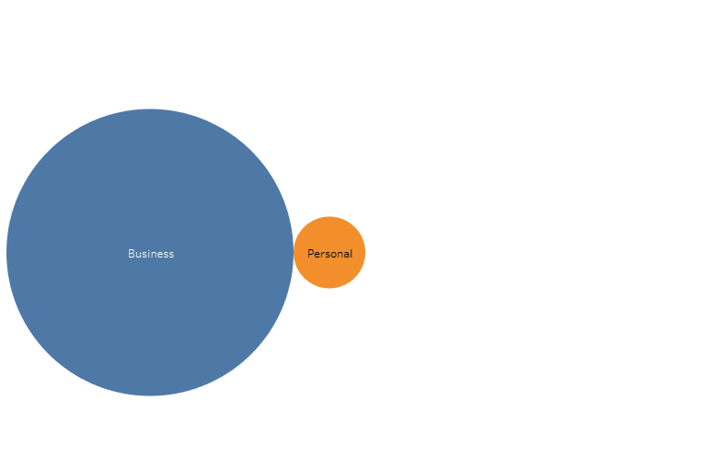

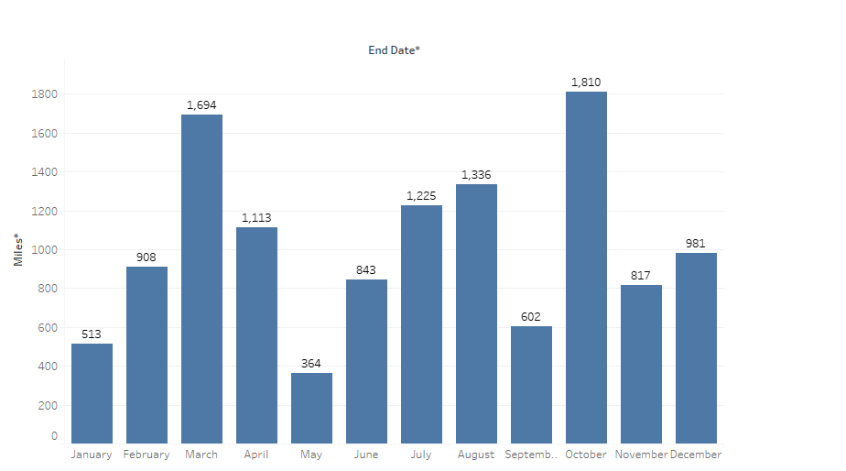

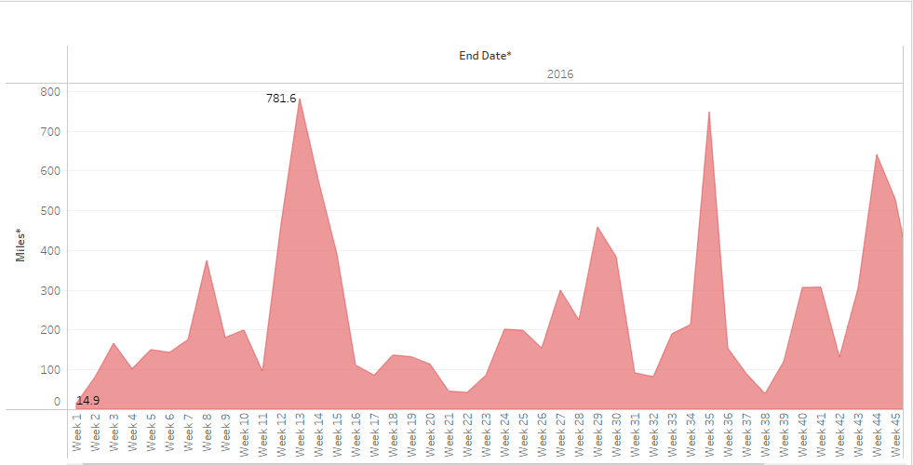

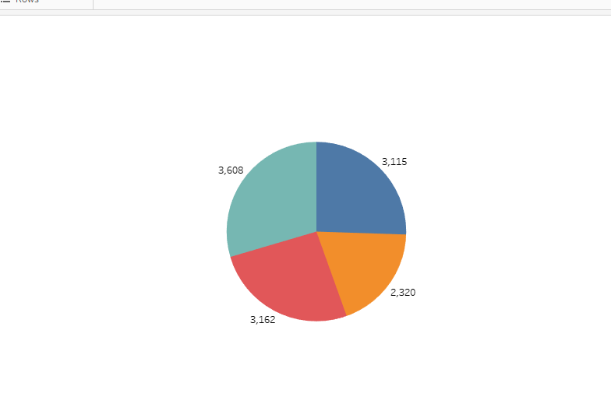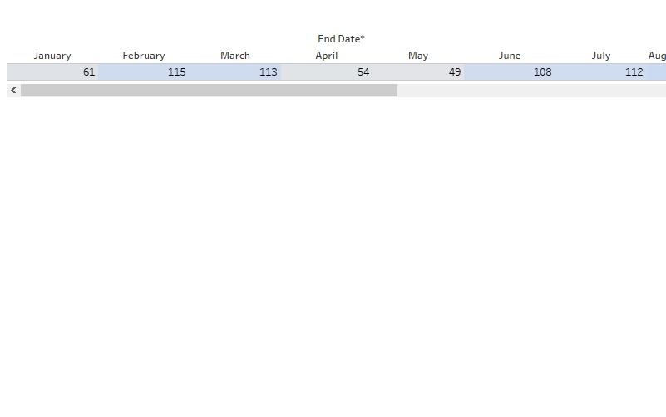

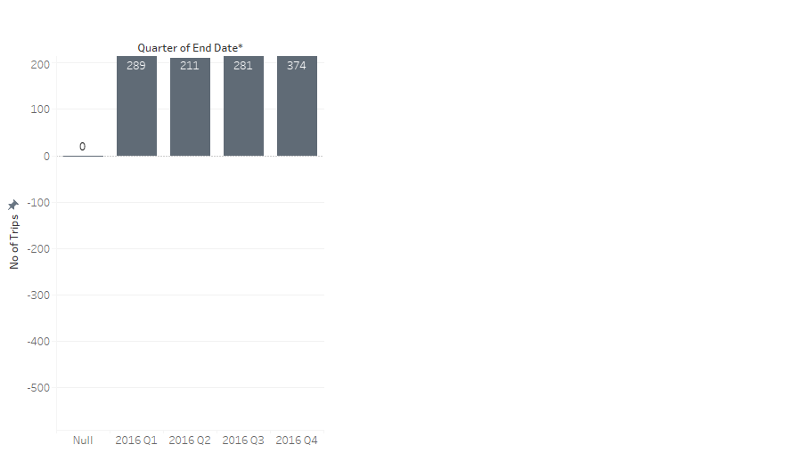



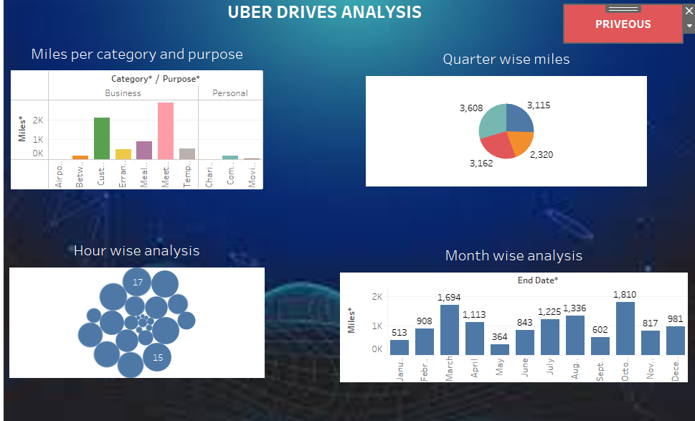



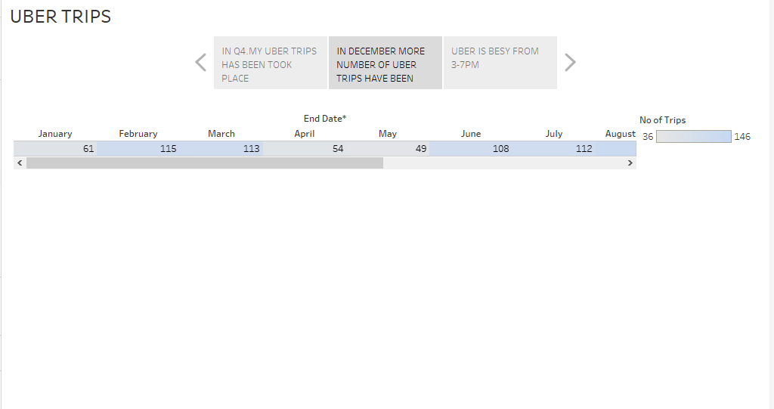

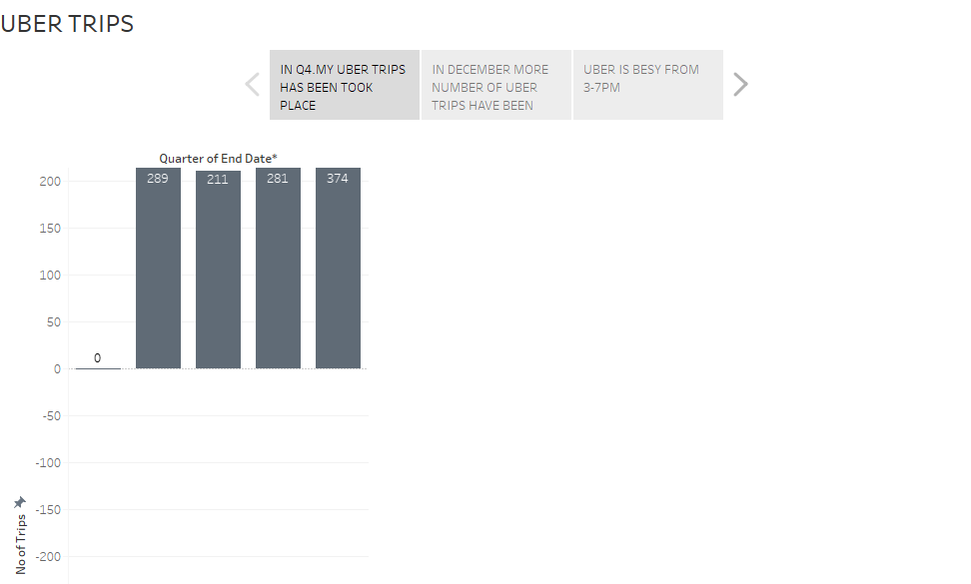

UBER Advantages and Disadvantages

# Advantages and Disadvantages of Uber

Advantages:

One of the disadvantages of Uber is its variable rate. Uber increase price in different occasions. Uber uses automated system to increase prices based on supply and demand. For instance, if you take a ride on New Year’s Eve or any other occasion, the fare is doubled or sometimes even tripled the normal rate. Dan Blystone in the article “The Story of Uber” mentions that in several snow blizzards occured in New York City in 2014, Uber increased the fare seven times the standard rate. This strategy outraged the customer and they provided negative feedback. Another disadvantage for the driver is that it become inconvenient. Most of the times when a driver wants to be taking fares and making money, but there are less passenger compare to drivers and it is frustrating for drivers who wants to work, but not getting any passenger. There are expenses that are not reimbursed for example wear and tear on the car. Drivers are responsible for all car expenses this can add up to significant added depreciation and maintenance and repairs on a vehicle. Uber service poses many advantages. First Uber provides ultimate flexibility for people to earn on their own schedule. An Uber driver can work as much or as little as they want and you can turn the app on anytime you want it. Not only it is flexible for drivers, but also it is beneficial for customers too. The ride is secure for both passenger and driver. There has been major crimes and victims both driver and passengers. Some passengers are raped and killed while most drivers killed because of cash. With Uber, you have security and peace of mind. Also, Uber is cheaper than any other type of rides. Taxi charges fare and the tip, but with Uber everything is included in the price you pay. Uber allow ride sharing also called carpool which makes it cheaper. Furthermore, Uber driver makes more money specially in some states like New York. For example, a New York Uber driver can make 70000$ a year. In addition, there is less dispute with Uber compare to traditional Taxi. For example, some people do not pay the taxi fare once they arrived their destination, but such customer cannot do with Uber since payment information is already taken.

UBER TRIPS EXPERIENCE:

We opened our API to developers globally over a year ago. Since then we’ve seen the creative ways that other apps have used Uber’s API to help get riders from A to B.  Buy baseball tickets on [StubHub](https://devblog.uber.com/stubhub-uber-your-golden-ticket-to-exclusive-events-2/) and you’ll get a reminder to book your ride when it’s time to head for the game.  It’s the same with [United Airlines](https://hub.united.com/en-us/news/web/pages/uber-on-the-united-app.aspx) for flights and [OpenTable](http://blog.opentable.com/2014/ride-there-with-uber-in-the-opentable-app/) for restaurant reservations.  And [Facebook’s Messenger](https://www.uber.com/newsroom/trip-experiences-api/https:/www.uber.com/newsroom/messengerlaunch/)lets you and your friends request a ride right when you are chatting.  These integrations help make life simpler and easier for people to get around.

During the holidays, we completed our billionth trip.  Added together that’s a lot of time riders spend in an Uber.  Which got us thinking … what if developers could also offer users of their apps new ways to enjoy themselves — or get stuff done — while they’re on the road?

So today we’re excited to announce the launch a new developer feature called Uber Trip Experiences which connects riders with their favorite apps at the start of a trip when they may have some time to spare.

Here are some of the ideas we are excited about.

*Entertainment:  10 minute playlists for a 10 minute trip*

**APPENDIX:**

[**https://public.tableau.com/views/VoyageVistaIlluminatinginsightsfromuberexpeditionaryanalysis/Story1?:language=en-US&publish=yes&:display_count=n&:origin=viz_share_link**](https://public.tableau.com/views/VoyageVistaIlluminatinginsightsfromuberexpeditionaryanalysis/Story1?:language=en-US&publish=yes&:display_count=n&:origin=viz_share_link)

**Google drive link:** [**https://drive.google.com/file/d/1NIVJ1NNhYOtYLFkBdTjXqvz4yqXpi33L/view?usp=drivesdk**](https://drive.google.com/file/d/1NIVJ1NNhYOtYLFkBdTjXqvz4yqXpi33L/view?usp=drivesdk)